**How java commands works?**

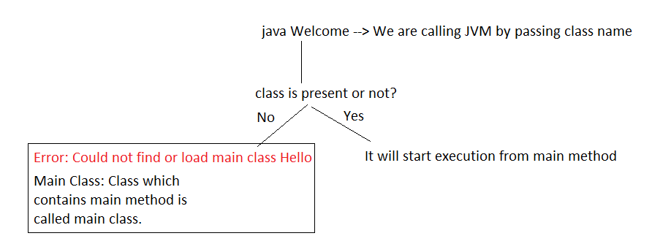

**Main() Method**

**Signature of main()**

public static void main(String args[])

**Why main() method is public?**

* Public is an access modifier.
* Access modifier decides visibility of resources.
* Public means we can access from anywhere.
* JVM is a different program, trying to call our main method. Hence main method must be public.
* If main method is not public then we will get runtime error saying **main method not found**.

**Why main method is static?**

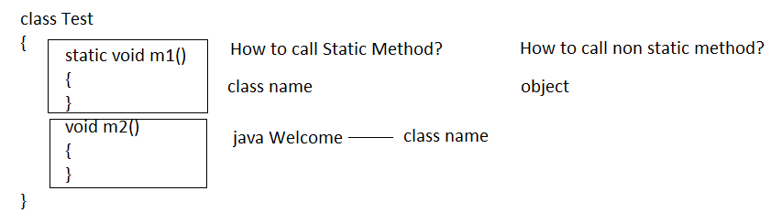

* We are passing class name to the JVM, JVM calls main method using class name, hence main method must be static.
* If main method is not static then we will get runtime error saying: **main method is not static**.

**void**

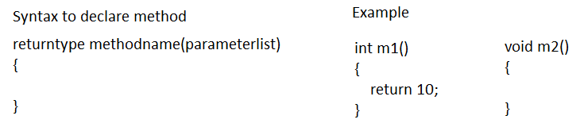

* It represents return type.
* void means nothing to return.
* If void is present then we will get compile time error saying invalid method declaration; return type required.
* We are not retuning anything to the JVM, hence main method is void.

**main**

* It is method name.
* We cannot change it.

**String args[])**

* It is a string array.
* It is used to store command line arguments.